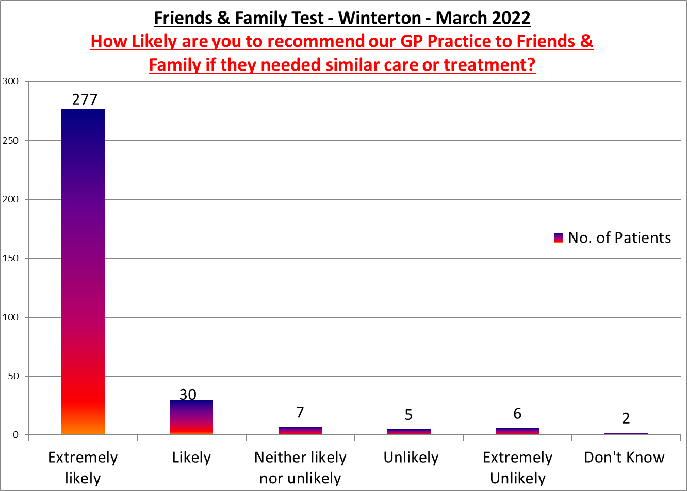

Winterton Surgery

**Positive Comments**

Nicola Bull is a lovely caring practice nurse.

The doctor was lovely and very helpful, thank you. Reception staff

Dr Ike was very good he explained everything clearly and told me how we were going forward. I left feeling confident that my problems were in good hands.

Really good service staff are all helpful and kind

Visit could not have gone better, happy with outcome

Dr Aung excellent care as always

A brill service , staff are very kind and helpful , nurses and doctors very kind and do a good job .

Really efficient and convenient text communication with Chris earlier in the week regarding minor surgery.

OK I find all staff helpful. Nurse especially. Had queries about my b12 injection. She listened and adjusted accordingly.

Nurse was brilliant and helpful. She had checked my files and asthma history.

Glenda the practice nurse was very attentive and considerate as well

I came for a blood test and the health care was very pleasant, professional in her approach, efficient with a lovely manner.

Brill service cannot fault it

Many thanks to Sarah for her help and support much appreciated

My warfarin levels are spiking, and I become anxious as I have had blood clots. I receive the upmost care, support, and guidance from the nurses. Paula

Dr Clarke was as always in my experience, caring, thoughtful, listened to me and have appropriate advice.

**Negative Comments**

Our appointment was 20 minutes late. We were taken in the room, explained the problems then asked to leave again to explain all over again.

I had a telephone appointment booked which didn't materialise. Had had a text to say I was due at the surgery

Dr phoned 35 minutes late and then ran out of time to finish listening to me and cut me off